1. There should be a scroll bar in the cart box also, because if a customer has more than 3 orders placed then the check-out tab is not visible. So need to have a scroll bar in the cart itself.

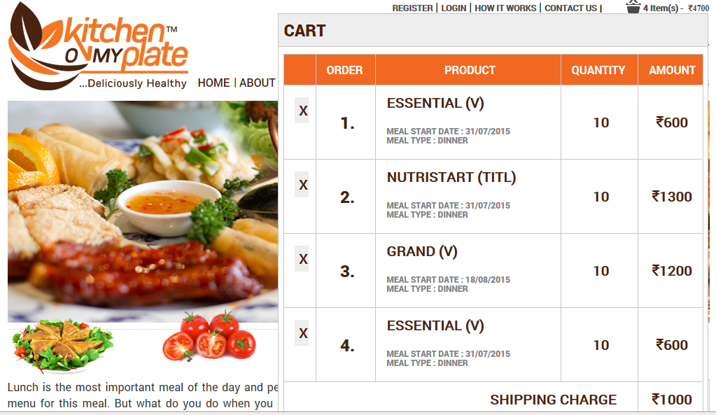

1. Order numbers are differing in the cart and in the final amount page.

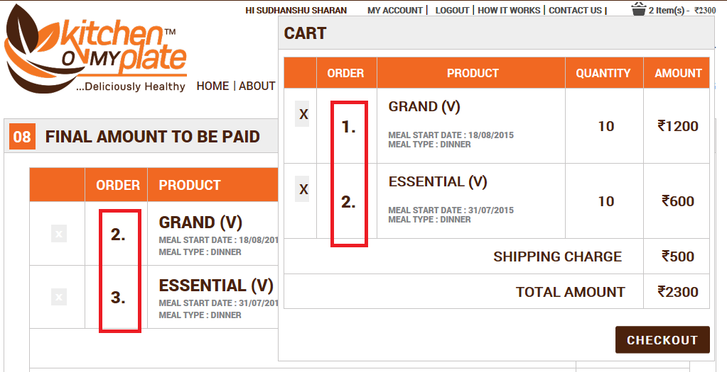

1. Remove take in turn option from the drop down box of select your meals in customized meal.

*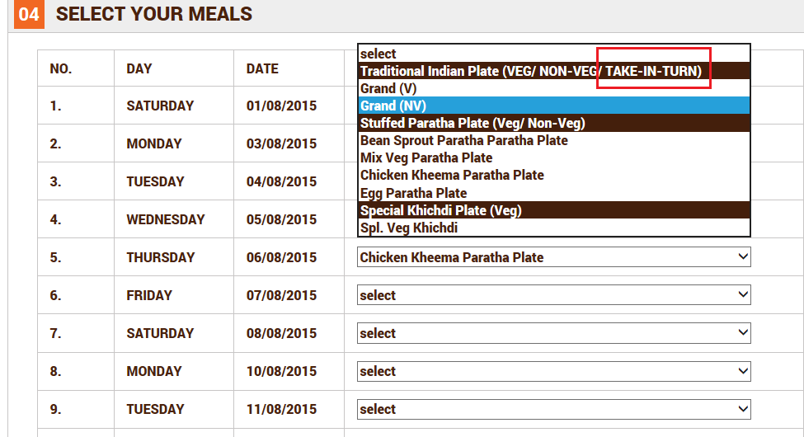*

1. VEG/ NON-VEG should be in Title case as mentioned in Stuffed Paratha and Special Khichdi and not in caps. Remove Take-in-turn.

*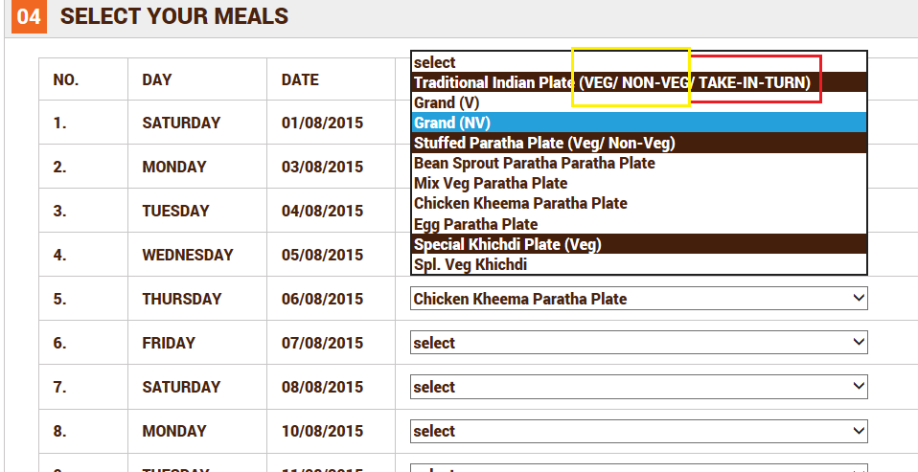*

1. Paratha is written twice.

*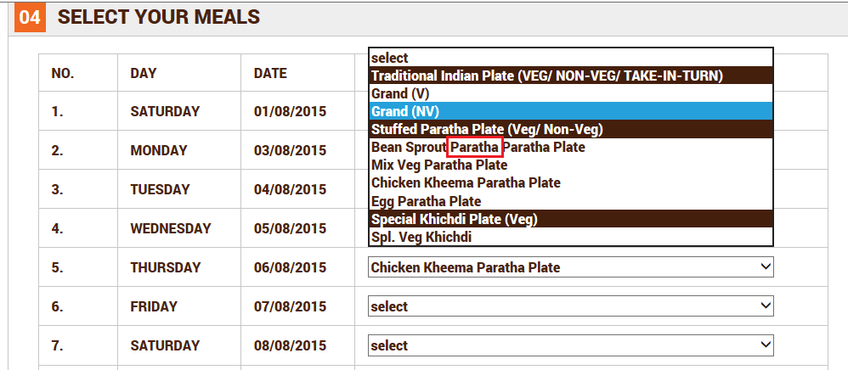*

1. Check delivery area is missing in customized plate .

*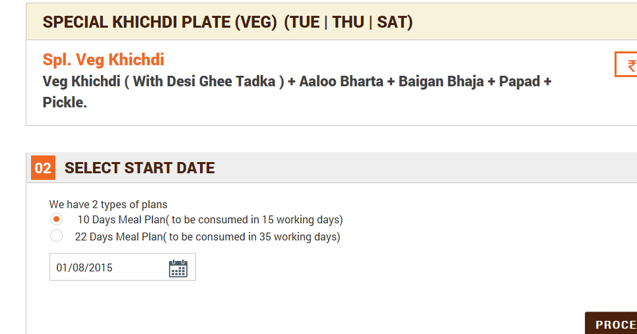*

1. After we go to step 5, and then click back then it doesn’t show the check your delivery area step. Step 02 should be visible.

*